# **Cagatay Uslu**

Amersfoort

23.05.2024

# **Implementing Microsoft Fabric for Data Analytics and Reporting**

## **1. Introduction**

This document is created for the case study for the MS team of XYZ bank to implement a scalable solution for their daily reporting activities with building dashboards. After the shift on the strategy from using a central Datawarehouse to a central datalake , a new approach is needed to access the central data which is efficient, cloud native, future proof, user friendly, and reliable.

### **1.1 Purpose**

This document provides a guide on implementing Microsoft Fabric to enhance data analytics and reporting capabilities within MS team of XYZ bank.

### **1.2 Scope**

The scope covers the explanation of the recommended solution for the MS team with using Microsoft Fabric.

### **1.3 Audience**

This document is only for the data professionals within Capgemini.

## **2. Overview of Microsoft Fabric**

### **2.1 What is Microsoft Fabric?**

Microsoft Fabric is an end-to-end analytics and data platform designed for enterprises that require a unified solution. It encompasses data movement, processing, ingestion, transformation, real-time event routing, and report building. It offers a comprehensive suite of services including Data Engineering, Data Factory, Data Science, Real-Time Analytics, Data Warehouse, and Databases.

Microsoft Fabric integrates separate components into a cohesive stack. Instead of relying on different databases or data warehouses, you can centralize data storage with OneLake. AI capabilities are seamlessly embedded within Fabric, eliminating the need for manual integration. With Fabric, you can easily transition your raw data into actionable insights for business users.

### **2.2 Key Features**

Microsoft Fabric is a cloud platform that provides a provides an integrated environment for analytics tools, including Power BI and Azure Synapse. It collects different data platforms within one portal for an easy control on data platform. The platform brings strong data storage, data integration and data transformation capabilities with an integrated data visualization tools.

### **2.3 Components**

Detailing the primary components of Microsoft Fabric:

* **Data Connectors:** Fabric comes with the strong data orchestration tool Data Factory which enables to build complex data flows and data pipelines with a rich data integration, data ingestion and monitoring capabilities.
* **Data Transformation :** Synapse Analytics as an integrated analytics service is a powerful data processing tool. Developers will be free to integrate data transformation with using SQL and Apache Spark Engine.
* **Data Storage:** One lake is a scalable and optimized storage option which provides seamless integration with various of data types, improved data governence, and faster insight from data through an integration with analytics and AI tools.
* **Visualization:** Fabric integrates with Power BI, Microsoft’s leading business analytics tool. That provides interactive dashboards with rich visualization options. Fabric also provides real time data visualization with live data feeds.
* **Analytics and AI Integration:** Microsoft Fabric integrates advanced analytics and AI capabilities to empower organizations with deeper insights and predictive analytics. Main futures are :
  + Automated Machine Learning
  + Forecasting and Anomaly Detection
  + Natural Language Processing
  + Advanced Data Processing (Data Enrichment, Image detection)
  + Automated Insights (Trends and Patterns in the data)
  + Integration with Azure AI Services (Azure Machine Learning, Cognitive Services)

### **2.4 Benefits**

MS team will be able to ingest data and build datasets from the central datalake of the company and also from third parties in will. Team will be able to manage their own data lake with strong monitoring tools within Azure, as well as data governance tool like Purview. Team has space to extend the solution in the future with adding multiple data warehouses next to the onelake for specific reasons. Data engineers will build data pipelines with enhance visualization tools. Solution is secure with enabling encryption at rest, Azure EntraID , RBAC controls, Key Vault integration. Future proof technologies like Azure AI, cognitive services will boost the efficiency within the team. Copilot integration is a big plus for the team to help for the work. Real time analytics capabilities will speed up data predictions. Synapse analytics has a powerful processing engine for big data analytics. Spark technology will allow flexible, fast data transformations integrated to the data pipelines with python notebooks. GraphQL integration allows applications to access data with API .

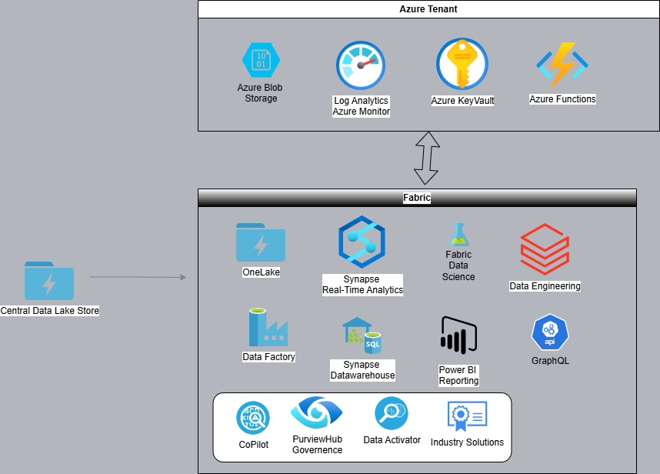

### **3. Conclusion**

I am a fan of Microsoft Fabric platform which enables compact data platform not only for entire organizations but also for data analytics and business teams to gather great insight within centralized data repository. A platform enables CICD development on multiple tools with a single management portal. It's important for the teams to improve data governance capabilities and Fabric has integrated solutions itself. A solution with full of options to make developers, data engineers and data analysts smile and gives motivation with lots of possibilities to improve the work.